ICON-BIO 2017- International Conference on Biological Applications of Nanoparticles
4th and 5th December IIT, Chennai
4th

REGISTRATION FORM
Dr./Mr./Ms. | Conference Registration details  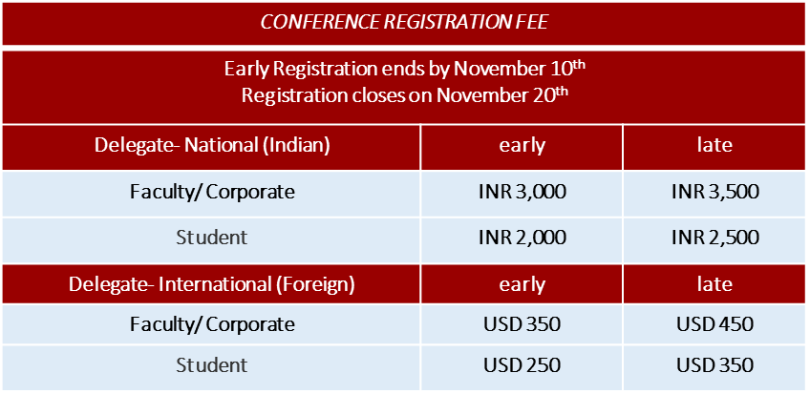  For discounts regarding bulk registrations, please contact.  aniruddha.b@scigenom.com  tessy.m@scigenom.com
Last/Family Name

First Name/Middle Initial

Degree (MSc/PhD/MD/Other(specify))

Title/Position

Department/Division

Institution

Street/Building or Post Office Box | Entitlement:  Registration includes entry to conference, conference material, lunch and refreshments as outlined in the program, banquet dinner and entry to cultural events
Email

Telephone No. | Payable Amount  Registration ____________________________________________  Accompanying person_____________________________________  Total Amount ___________________________________________
City/State or Province

Pin code/Postal code/Country

Accompanying Person (Spouse/Guest), if registering

Registration Type  - Academic/Government  - Commercial/Corporate  - Student  - Accompanying Person | Mode of Payment (Tick mark the opted)  - DD/ Cashier’s cheque  Date of payment:  Reference number for transaction:  - Wire transfer  Date of payment:  Reference number for transaction:
Contact:
Dr. Aniruddha Bhati, M: +91-9633565461, E mail: aniruddha.b@scigenom.com

